**Lab 12 - CIS 452**

1. **Perform the following operations and answer the associated questions:**
   1. **Access the man pages, what is the difference between stat(1) and stat(2)?**

stat(2) is the system call we can use in C whereas stat(1) is the command that stat(2) uses. We use stat(2) when calling it directly from the command line.

* 1. **Compile and test sampleProgramOne. Run it twice: use the sampleProgramOne source code file and then its executable file as test inputs. What *exactly* does sampleProgramOne do?**

The program takes a file as an input and outputs the mode (the file type) and the inode (the file’s serial number).

* 1. **Modify sampleProgramOne so that it reports whether a file is a directory or not. Verify that your program works. Include a screenshot of the execution. Also, include your source code as an attachment when uploading to Blackboard.**

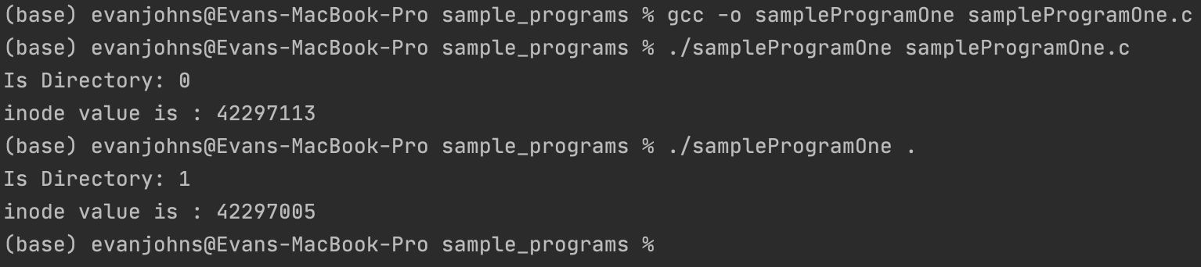

1. **Perform the following operations and answer the associated questions:**
   1. **Compile and test sampleProgramTwo, what exactly does sampleProgramTwo do?**

The sample program outputs all filenames in the current file’s <filename: inode#> Tuple. Simply put, the program displays all files in the current directory.

* 1. **Verify and demonstrate the correctness of your program by testing it against the ls program using your current directory. For example ‘ls -l’ should return the same value as ‘./sampleProgramTwo’. Submit your modified program and include a screenshot of the execution**

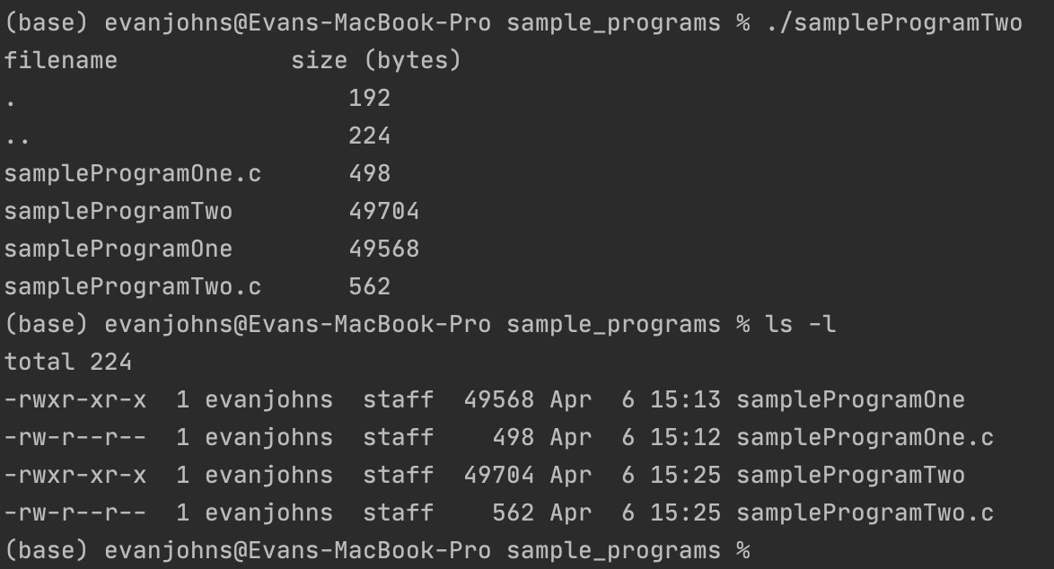

1. **Answer the following questions:**
   1. **Use du to report the usage of all files in some of your directories (be sure to choose some with subdirectories), based on the *order* of information provided, which of the two tree traversal algorithms does du use?**

It would appear that du uses depth-first search, as du is going to the first directory, displaying everything there until nothing is left, returning to the parent directory, and repeating.

* 1. **What is the default block size used by du?**

The default block size used by du is 1028 bytes or 1 kilobyte.

* 1. **Speculate: given the intended purpose of du, why is the usage reported in blocks, instead of bytes?**

Most likely because there is never a file smaller than one block, and since the filesystem works in blocks, it makes more sense to display each file’s size by blocks.